Ques 4:

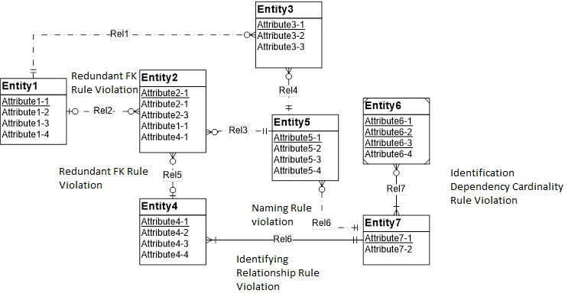

1. Resolution of the identifying relationship rule: Adding one or more weak entities or making the relationship (Rel6) non-identifying can be the solution.
2. Resolution of the identification dependency cardinality rule: Change Entity 6’s cardinality in Rel7 to (1,1).
3. Resolution of the redundant FK rule: Remove the redundant foreign keys (Entity2.Attribute1-1 and Entity2.Attribute4-1).
4. Resolution of naming rule violation: Rename either of the relationship Rel6.